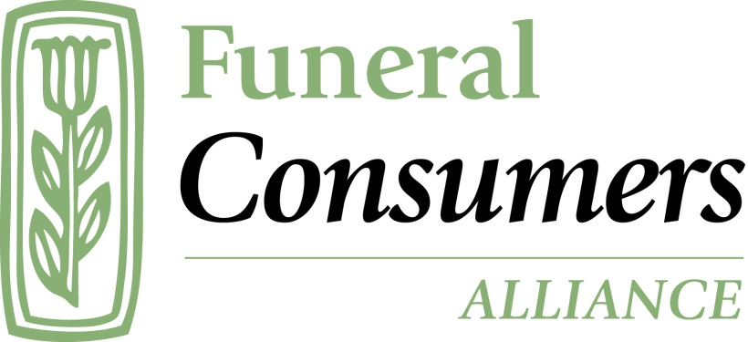

Your One-Year Fundraising Plan
for affiliates of Funeral Consumers Alliance, Inc.
2020

Page 2. Introduction

Page 3. The four elements
a. The ‘ask’
b. The mechanics: letters and envelopes
c. Thanking and reporting
d. The calendar

Page 5. Sample letter 1

Page 7. Sample letter 2

Page 10. The mechanics: envelopes and reply devices

Page 13. Thanking and reporting

Page 14. Outer mailing envelope

Page 15. Inner return envelope

Page 16. Reply device and checklist

Page 17. The calendar

Page 19. More help and resources
Introduction

Raising money to make your good work happen is fundamental. No nonprofit can skip over this. Volunteers form the backbone of our mission, but volunteer hours don’t pay for your postage, your website, your printed materials, or any of your other expenses.
Fundraising is to nonprofits as sales are to businesses. That is, fundraising is both necessary and legitimate. Nonprofits need money to the same degree that businesses do. Many of us join nonprofits because we care about the cause. We sometimes feel guilty about asking for money, but we shouldn’t.

This is why too many nonprofits struggle to fund the basic needs of their modest budget every year. It doesn’t need to be this way. The members and donors who belong to your organization want to make a difference in the world and they want to give their money to your organization to make it happen. You’re not going to “offend” members. They’re not going to tear up their membership. We know this at FCA national because we went from that stage to a more assertive direct mail fundraising program. Our end-of-year fundraising doubled in one year by following the practices discussed in this guide.

This guide gives you a simplified one-year plan for fundraising. It relies on direct mail, paper mail, with email “asks” to support it.
Why? Because paper mail fundraising letters outperform email alone. How much? Only 8.5 percent of donations that went to nonprofits in 2018 came from email fundraisers. More than 90 percent of donations to the entire nonprofit sector, today, come because of a piece of paper that physically shows up in your mailbox.
Go check your own mailbox right now. See that appeal from the American Red Cross ($2.6 billion in revenue in 2019)? What about that one from the Nature Conservancy ($1 billion in revenue in 2019)? Why are they sending you paper mail? Because they know it works. They get most of their donations from direct mail.
These large charities know what they’re doing. They’re not finding ways to get rid of paper mail in favor of email alone.

Key Points

- Your fundraising success is going to come from well-crafted, well-time paper-based appeals. Learn from the “big boys” in the charity world. They wouldn’t be doing paper mail if it weren’t profitable.
- You have to ask more. The biggest reason that donors cite when researchers ask them, “Why did you not make a gift to charity X?” is “They didn’t ask me.” We recommend you send a fundraising appeal at least four times per year to your membership/mailing list. Scared? You’ll get past that. Guess what happened when FCA national started doing that? Our donations improved, and we got compliments from many longtime members. They were happy to hear the kinds of real-world consumer problems their gifts could solve, and they were happy to give.
- Organizing a calendar, organizing your letter, reply cards, return envelopes, etc., is key. You will put the work in up front. The first time you do this will be the most work (but it’s not that hard, and we have templates below). Once you set it up, you can re-run it like clockwork. What seemed like a huge leap becomes normal, and your whole board will feel pleased to see the gifts come in at a higher rate.

The 4 Elements You Need for Successful Direct Mail Fundraising

1. The “Ask”—That’s fundraising speak for your pitch letter, your request. Another way it’s described is as your “offer”. You are offering your members a chance to solve a real problem, experienced by real people. This is where storytelling comes in. You will write up brief stories about the members and consumers who contact you to ask for help. Crucially, your letter will tell this story to the reader and let her know that she can solve this problem with a gift. The tone is direct, conversational, and appropriately emotional (emotions motivate giving; facts and statistics don’t).
You’ll see two sample letters below used successfully by FCA national. We’re here to help you write your own, too, based on these principles. Call on josh@funerals.org.

2. The Mechanics and the Paper Pieces—These are the actual, physical pieces that must all be used together in each mailing. Every element is crucial; if you don’t include all of them, you’re wasting your money on a fundraiser that won’t bring in much. Again, this is a do-it-once-at-the-beginning job. After that, all you have to do is alter dates and sometimes a bit of language. Set it up in the beginning, and you have master template files. Easy.
- The letter itself
- The “reply device”—a separate, stand-alone, fill-in card to return by mail.
- The outer mailing envelope
- The return envelope addressed to your FCA (not postage-paid)

3. The Follow-Up: Thanking and Reporting—Of course, you already know that every gift needs a kind thank-you letter (also for tax-deduction purposes if you’re a 501(c)(3) ). But it goes beyond that. Your newsletter should always include a section where you tell your donors and members the good work they did with their gifts. Just like in your “ask” letter, you’ll speak directly to your reader like this:
“Your gifts to FCA of Anycity help real people, even though you won’t know all of their names. Let me tell you about Arlene. She called us for help when the funeral home would not honor all the items in her husband’s prepaid funeral contract. FCA of Anycity then contacted. . . .[the rest of the story].”

These are short and sweet, but they tell stories about the real work that happens when consumers call and write to you. Examples are found below in FCA National’s newsletter.
Get Personal
The more personal your thank-you letter, the better. If you can hand-sign thank you letters or hand-address the envelopes, this is a great project to split up among your board and volunteers. Personal thank-yous are especially important for large gifts. A phone call from a board member to a generous donor is always a good idea.

4. The Calendar—Plan for one year, and get your dates on your calendar at the beginning. This will set you up for a clockwork operation throughout the year. We suggest you mail four times per year, but you can start with less. If you only mail a newsletter/appeal to members once per year, start doing it twice, for example.

The end of the year between Thanksgiving and Christmas is the most generous time of year. People give the most gifts then, and the calendar will concentrate on this time of year in more detail because it will be important to your bottom line.

The dates we suggest are guidelines; you may not be able to hit them exactly, and that’s fine. Just try to be reasonably consistent. That is, have a spring appeal, a summer appeal, a fall appeal, and a holiday-season appeal (or one in spring, and one at the holidays).
Real-word Sample Letter 1

February, 2019

John and Jane Doe
123 Main St.
Anycity, MA 00000

Dear John and Jane,
You’ve been a friend to grieving people around the country who will never meet you. Because you give to Funeral Consumers Alliance, families from all walks of life get factual information about funerals and save untold thousands of dollars when laying their loved ones to rest. It’s my responsibility to ensure that you know the real-world effect your gift has on real people.
“Your gift doesn’t just go into the bank. It puts a caring, knowledgeable voice on the phone to counsel the thousands of families who come to FCA every year for the help only you can give. “

Here are two opportunities for you to be a “silent hero”. You can help solve these families’ problems right now. That’s what your gift does. It doesn’t just go into the bank. It pays for research on state laws to help families with complaints. It puts a caring, knowledgeable voice on the phone and an online to counsel the thousands of people who come to the FCA national office for help every year.

You can help Daniel

Almost ten years ago Daniel bought a life insurance policy to tide his family over when his death came. The rent, the lights, food, and yes, funeral expenses were all on his mind when he thought of his wife and children’s needs. “But I let myself get talked into signing it over to a funeral home during a difficult time,” he says. “But I don’t want a $14,000 funeral; I’m just going to be cremated.”
Daniel is stuck between an insurance company and a funeral home. Each one says the other didn’t complete the transfer paperwork correctly. They’re holding Daniel’s money hostage for no reason Daniel can discern. What will he do? When you give to FCA you’re making sure Daniel talks to a competent advocate who can help him get his money back!

Have you ever been to a country where you couldn’t speak the language?

Though I brush up on my conversational French when I drive to nearby Montreal, there’s always that one moment with a hotel desk clerk where it fails me and I feel mortified.
Imagine how it feels to be a Spanish-speaker in the US, part of an immigrant family, and you have to arrange a funeral. You’re not used to the customs (and the business) of American funerals. You can’t speak much English. You’re facing grief, the pressure to conform to a new cultural practice, and you can’t, even ask for detailed help.
This happens every day in the US and you can help change it. Concrete example: a gift of $250 will pay for a Spanish translation of one our two-dozen brochures on basic funeral planning and a family’s legal rights. One of you reading this letter is a special person who got the ball rolling with our first translation, “How to Choose a Funeral Home the Smart Way.”
Friend, will you be the next hero? You can help us bring “Cremation Explained,” or “How to Pay for a Funeral”, to millions of Spanish speakers with a gift today. As soon as the translations are complete, they’re posted on funerals.org in our Spanish section. The paper versions are helpful for requests from around the country when families don’t have Internet access.

Your gift does “big picture” work, too. You know from reading our newsletter that we’re pushing hard in Washington to convince the Federal Trade Commission to require funeral homes to post their price lists online. You can help us make the case! A gift today will help us survey all 770 funeral homes in the state of California to see how many post their prices. What you invest in this project will blossom into media coverage throughout the Golden state, prompting millions of people to wake up to the high cost of funerals and shop before they drop!
Spring is coming, friends, and it’s going to be a good year with your help. Thank you. I can’t wait to report on the work you made happen.

With all of my gratitude,
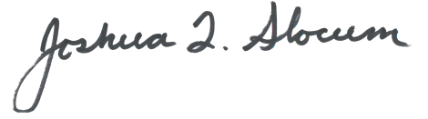
P.S.—What would you like to know about the specific ways you help grieving people through your support of FCA? What kinds of stories can we share with you about the “on the ground” work that you don’t get to see?
Give us a call, or drop us a note. When you do, please help us get to know who you are. Tell us your story. Getting to know you is a gift to us.
802-865-8300, or fca@funerals.org

Thank you!

Joshua Slocum
Executive Director

Real-world Sample Letter 2

November, 2019
First Last
Street 1 or 2
City, State, Zip

Dear First,
Edith was married to her husband for 46 years. Then one morning Clyde didn’t wake up with Edith.

Instead of planning sleeping spots for the grandkids at Thanksgiving, Edith was picking out Clyde’s plot.

The cost for the funeral and the plot were going to be $8,500 – cash that Edith didn’t have.

So suddenly Edith is putting her house on the market to pay for the funeral . . . and looking at being homeless.
Losing a husband is bad enough, but losing your house to lay him to rest is a tragedy no widow should have to face. It’s a choice no family should ever have to make.
You can stop this for a widow right now. Yes, I’m serious. You can make sure Edith doesn’t have to lose the roof over her head and the walls that hold the photos of a half-century marriage.

Will you make a gift by midnight, December 31? It costs just $50 to give someone like Edith what she needs to bury her husband with honor and not have to sell her home. Let me show you how.
When you make a gift you’re giving Edith the exact information she needs to get a funeral at a reasonable cost—so she won’t have to sell her home or anything else.

You’ll do it by providing Edith with time on the phone with the only experts who can really help. Because what Edith (and so many elders like her) needs is information. She needs the truth about funerals!

Like most of us, Edith only thinks to call the closest funeral home in town, the one her family has used for every death. And, well, $8,300 is just “what a funeral has to cost these days,” right?
Wrong. And this is where you come in. Your $50 gift can save Edith enough money to keep her home. That’s because your $50 grows into something a lot bigger than the cost of dinner for two.

Your gift provides:

- Phone counseling with people who know how to help Edith find a funeral home with prices she can afford. She doesn’t know it yet, but the same service she wants for Clyde is offered at almost half the cost at a funeral home 15 miles away. If she considers cremation, Edith will save thousands more.
- A referral to a local, volunteer-run Funeral Consumers Alliance chapter that can recommend reasonably priced, upstanding funeral homes that give service, not a sales pitch.
- A listening ear and hand to hold during a tough time. You’ll reassure Edith that her love for Clyde doesn’t have a price. It can’t be bought for $8,300, or eight-million-dollars. There is no shame in burying our dead within our means.
Edith needs you. The thousands of grieving families that call us, write to us, or visit our consumer website need you. Your gift will help a family make final arrangements that fit their emotional and financial needs.

We are the only nonprofit in America who can provide this service for families in need. And it doesn’t happen without your support.

I appreciate that you care about these families, and I’m honored to be able to write you to ask you to help a grieving family.

Will you help a grieving family with a $50 gift today?
Right now there are families who are agonizing over whether to sell the house, or the car that gets them to work. And they’re doing it in grief.

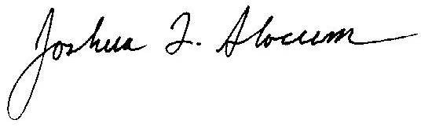
All they need is a lifeline. Someone who can listen, and then provide the exact expert advice they need. Your gift today gives that lifeline to a family!
Sincerely,
Joshua L. Slocum
Executive Director
PS—When you make a gift by December 31, 2019, your money will be doubled up to $8,000 thanks to some generous donors! You’ll double the number of families you’ve helped this holiday season!

Key Points About The Letters Above

- Letter 2 is better than Letter 1. Letter 1 performed well, but Letter 2 performed even better. Why? We had some in-person training followed up by critique and copy-editing by the instructors from our fundraising retreat. Letter 2 is more concise, punchy, and to the point. Letter 2 also dropped the bad habit of thanking the donor in the same letter in which we were asking her to make a gift to solve a problem. It’s tempting to thank them when you’re asking for money, isn’t it? But it’s a mistake. Your letter needs to create a sense of urgency, showing a problem the donor can solve. If you’re thanking the donor before she gives, you’re leaving her with the impression that the problem has really already been solved. Why should she give?

- They tell stories about real people, and the real-life consequences families face when planning funerals. Yes, these are real examples from consumers who’ve contacted us, even though we gave them pseudonyms to protect privacy. You have these stories too, even if you’re thinking as you read this that you don’t. Even that five-minute conversation you had with a widower looking for an affordable cremation can become a compelling narrative worthy of a fundraising letter. Josh@funerals.org can take your anecdote and craft a letter, coaching you on how to do it yourself next time.
- Notice how the letters speak directly to the reader, and use the word you a lot. It’s deliberate because it works. The goal here is to show your potential donor how her gift becomes real-world help to a real person whom any of us can identify with. Donors give to solve problems. They don’t give to “support us” or “help our work.” Erase bland/nice corporate-speak. Get specific, and write in the vernacular. This is a well-tested-and-confirmed approach.
- The best part—letter number 2, above? That brought in $30,000 during our holiday fundraising season of 2019-2020. Twice as much money as we brought in the same time the prior year. Yes, we bolstered it by sending emails reinforcing the letter as the end of the year drew to a close. You can do it, too!

The Mechanics: Envelopes and Reply Cards

These are details that matter. Failing to do them right will compromise your fundraising. If you’ve gotten this far, don’t take short-cuts now and waste your good work. What happens if you do? Not including a pre-addressed return envelope will cut your donations in half. Not including a reply card (also called ‘reply device’) will cut your take, too.
ONLINE GIVING!

Getting your paper letter into people’s hands is crucial, but we don’t care if they pay us with a paper check or if they donate with a card online. If you don’t have donation capability on your website, get it going now. Every obstacle you place between the donor and her ability to give cuts the number of donations you’ll receive. Online donation capability is a must. Not having it is an annoying obstacle to your donors. Be sure your reply device points to your website’s donation page, too.

(samples begin next page)

Outer Mailing Envelope—#10 size

Nonprofit Organization
US Postage Paid
Burlington, VT
permit 478

Funeral Consumers Alliance
33 Patchen Road
South Burlington, VT 05403

Inner, Inserted #9 Return Envelope

Place stamp here

Funeral Consumers Alliance of Anycity
123 Main St.
Anycity, Anystate, 12345

Reply Device—Stand-alone, pre-cut, not attached to other paper

Use this checklist to make sure you have every crucial piece in your reply device:

___Does your terminology mirror the language in your pitch letter? This example matches the “I’ll help X-number of families” used in our recent campaign. You don’t have to put a price tag on how much it costs to spend, say, 15 minutes on the phone with a family, for example, but it helps.
___Do you have an “ask string”? That’s the different monetary levels suggested. Don’t go below $50, or you’ll get more $25 donations. Start with $50, and you’ll get more $50 donations.
___Did you make sure the donor’s name and address was printed on the reply device too? Yes, it makes a difference. It also helps your record-keeping.
___Did you give space to write a credit card number?
___Did you make sure to include a line for the expiration date?
___Did you make sure to ask for the three-digit code on the rear of the card?
___Did you make sure to give a signature line?
___Did you point the donor to your online giving page with a link?
___Did you make sure to put a tracking code that tells you which mailing/campaign generated this donation? In the example below, our code is 2019EOY. That tells us “this gift came from our end-of-year fundraising letter in 2019.”

Notice—We laid this reply device out twice in a document to allow our print house to cut multiple slips from the same sheet. Ask your print house questions about what they need.

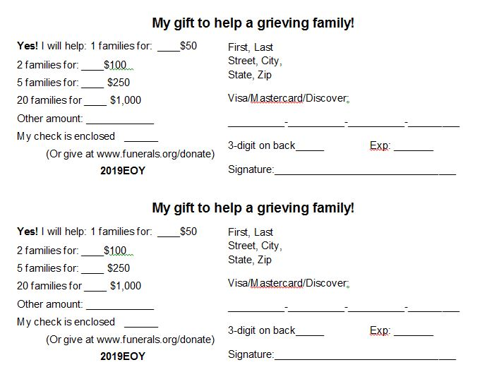

Thanking and Reporting: Sample Newsletter Piece

Key points:
- Each newsletter needs a section where you report the good work donor gifts have accomplished. This is where you thank your members and donors explicitly, and by showing them the actual results. Tell them about the family you saved $3,000 for by pointing them to your price survey; tell them about the couple you helped find a cremation they could afford, etc.
- It’s short, no more than four-pages. Some of you will remember when FCA National’s newsletters were much longer (your executive director came from newspapers, and needed to be trained out of treating a newsletter like the Sunday Times). There’s a truism in fundraising: “No one reads your newsletters.” That’s only a slight exaggeration. Readers skim and move around; few sit down to read a charity newsletter cover to cover. Use it to inform members about information they need—annual meetings, new price surveys, new forms available, legislation you’re working on—briefly, but see it as an investment in your fundraising. Leave them feeling good about the gifts they make.
- You’ll see screenshots below. After that, you’ll see a readable text excerpt of the “thank you” portion you can use as a guide.

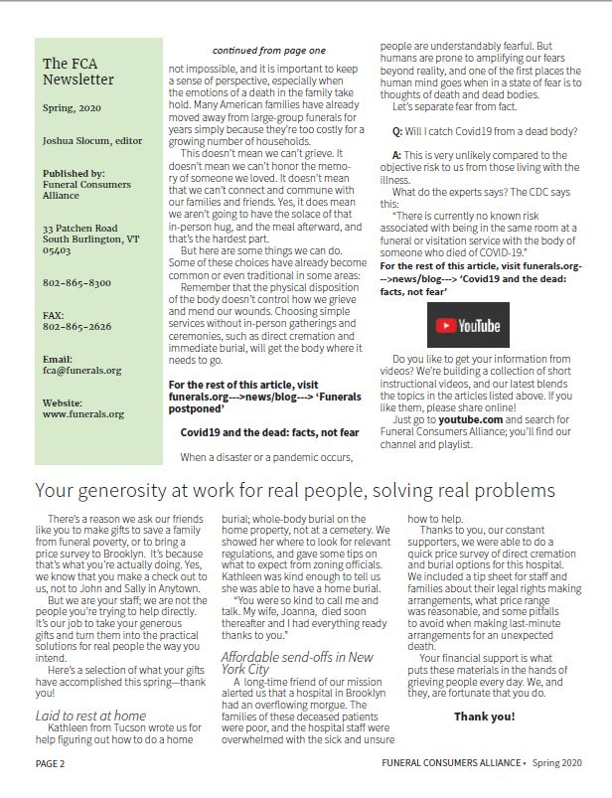

Text Excerpt of Thank You Section

Your generosity at work for real people, solving real problems

There’s a reason we ask our friends like you to make gifts to save a family from funeral poverty, or to bring a price survey to Brooklyn. It’s because that’s what you’re actually doing. Yes, we know that you make a check out to us, not to John and Sally in Anytown. But we are your staff ; we are not the people you’re trying to help directly. It’s our job to take your generous gifts and turn them into the practical solutions for real people the way you intend.

Here’s a selection of what your gifts have accomplished this spring—thank you!

Laid to rest at home
Kathleen from Tucson wrote us for help figuring out how to do a home burial; whole-body burial on the home property, not at a cemetery. We showed her where to look for relevant regulations, and gave some tips on what to expect from zoning officials.
Kathleen was kind enough to tell us she was able to have a home burial.

“You were so kind to call me and talk. My wife, Joanna, died soon thereafter and I had everything ready thanks to you.”

Affordable send-offs in New York City

A long-time friend of our mission alerted us that a hospital in Brooklyn had an overflowing morgue. The families of these deceased patients were poor, and the hospital staff were overwhelmed with the sick and unsure how to help.

Thanks to you, our constant supporters, we were able to do a quick price survey of direct cremation and burial options for this hospital. We included a tip sheet for staff and families about their legal rights making arrangements, what price range was reasonable, and some pitfalls to avoid when making last-minute arrangements for an unexpected death.

Your financial support is what puts these materials in the hands of grieving people every day. We, and they, are fortunate that you do. Thank you!

Your One-Year Fundraising Calendar

The calendar below gives you suggested dates for sending your fundraising pitches. You’ll see that we pay extra attention, and suggest extra steps, for your end-of-year fundraiser. Those extra steps include sending emails to the same mailing list that you are sending paper mail to. These emails should be shortened versions of your pitch letter. Each successive supporting email should be shorter; just cut more text each time, focusing on the most important message. As you get closer to the end of the year, these emails should get more urgent. For example, “Time is short! Please give by December 31, 20XX. . .”

Supporting emails always help any campaign; don’t be afraid to use them any time. Don’t have emails for every one of your members? Send to those you do. And then, make a point of collecting emails. In each of your newsletters, put an eye-catching box that says to the reader something like, “Please update your email address with us! We want to make sure you get FCA’s news and member alerts. Send us your name and email to fcaofanycity@gmail.com. Thank you!” Repeat this, then repeat it again, then keep repeating it. Repetition is crucial to prod people to action, both for donations and for updating their contact information.

March/April—Your spring fundraising letter. Even if you decide not to do a stand-alone fundraising letter, make sure your spring newsletter carries it. An entire page, and a complete letter that tells a story, not just a little box timidly asking for “contributions to support our work”.

June/July—Your summer fundraiser

September/October—Your early fall fundraiser

End of November, beginning of December, your important end-of-year campaign. If this is your first time, you’re going to think we’re asking you to “send too many emails”. Go with us, and take the leap of faith, because it works. You need to do what seems like “over-communication” at the end of the year. Repetition creates urgency, and it helps people notice your campaign. Remember, not everyone you mail to is going to read your letter, or read it right away. Remind that donor of the need to give with several emails leading up to the end of the year.
Every charity that does good fundraising is “over-communicating” because it works.

Are you nervous about disgruntled responses? Remember that people who complain a) a small percentage b) should not take up so much space in your mind that you neglect the greater number of people who give. Everyone who says, “I don’t want to receive this piece of mail/email,” of course, should get a polite response assuring them you will mark their records not to receive whatever it is they don’t want to receive. Treat them as you would like to be treated when you request to be removed from a mailing list.
Here’s our experience at FCA National in 2019 when we adopted the system described here. We mailed almost 10,000 pieces for our end-of-year-fundraiser. We were able to follow up with three end-of-year supporting emails to about a third of that list.
Guess how many complaints/requests to be removed we got? Four out of 10,000 pieces.

- Have all your copy, envelopes, reply devices, and every element, already done by the beginning of November (hopefully earlier). Make sure you share these with your print house ahead of time to work out any problems. Absolutely ensure that your print house knows that the letter should be put into the mail in time to have it hit mailboxes just after Thanksgiving. Timing matters.
- Have your letter arrive in mailboxes hopefully the day after Thanksgiving or shortly thereafter. Again, this is when your letter should arrive in your members’ mailbox; not the date your print house should mail it. It needs to be mailed earlier and timed to arrive then.

- You’ll want to follow this letter up with three emails close to the end of the year. Be sure there’s a clear, large-type link to your donation page in each email. Model these on your letter, but with each email that gets closer to the end of the year, shorten it. Take out detail, leave the main “ask”, and be sure to encourage donors to “give by December 31st!”. Be frank. You need money to help members and the public, so say it directly. For example:
“Your gifts help grieving people. Without them, we can’t solve these problems for families facing a death. They’re confused about options and worried about price. You are FCA of Anycity, and we are the only charitable group that specifically helps the bereaved at the worst time of their life while they face one of the most expensive purchases they’ll make. Please give generously by December 31st!”

December 27—email one
December 30th—email two
December 31—email 3

Getting More Help and Advice

This guide is a simplified adaptation of course work we learned in an intensive fundraising retreat in the fall of 2019, and from the Nonprofit Storytelling Conference held annually. The companies and people behind these events are top-notch. They’ve done the qualitative and quantitative research; they back up and proved everything they said.
Our experience at FCA National proved them right. When we put this system in place in 2019, our end-of-year fundraising doubled. We went from $15,000 in donations to $30,000.

Check out The Better Fundraising Company and the Nonprofit Storytelling Conference. Just search those terms online and you can’t miss them. We recommend you sign up for their free webinars and videos. The staff host frequent livestreams with examples of good and bad fundraising letters, ways to make online giving easier, and a lot more. You’ll also get ideas for online fundraising and special or occasional email-only fundraisers. While direct, paper mail is going to be the main source of your donations, emails and social media posts done right, at the right time, can both bring you in extra donations you weren’t expecting and support your overall campaign throughout the year. The more you stay in touch with members and donors, the better your results.

Call on us at the national office for personalized help. We’ll coach you on drafting your campaign letters, critique what you have, and answer questions about timing, postage rates, and more. Funeral Consumers Alliance groups are seen as niche, small, and “focused on one very specific/kinda weird thing.” We’re all used to people only discovering us at the last minute when they need us, and to hearing “I never imagined there was a group like you.” It’s amazing how far the denial of death goes in the American mind, eh?
But we don’t have to be destitute. There’s no reason your small, local group needs to have a bank balance of $300 while your board worries about how to pay for the next printing. The money you need to fulfill the mission is already out there in your current members’ hands.

Good luck!

